

American International University-Bangladesh (AIUB) Department of Computer Science

Faculty of Science &Technology (FST)

Semester:2022-2023, Fall

Section: E

Online based food delivery system -(Food Panda)

**Group-06**

A Report submitted

By

|  |  |  |
| --- | --- | --- |
| **SN** | **Student Name** | **Student ID** |
| 1 | Amir Hossain | 19-41149-2 |
| 2 | Md. Mahin Hasan | 19-40345-1 |
| 3 | Fahmida Haque | 19-40408-1 |
| 4 | Lokman Hossain | 19-40406-1 |
| 5 | Nafis Sadik | 18-38230-2 |

Under the supervision of -

**FARZANA BENTE ALAM**

Software Test Plan

for

Online based food delivery system -(Food Panda)

Version 1.0 approved

American International University-Bangladesh (AIUB)

**10-Dec-2022**

Table of Contents

Revision History 2

1. TEST PLAN IDENTIFIER: FoodPanda1.3 3

2. REFERENCES 3

3. INTRODUCTION 3

3.1 Background to the Problem 3

3.2 Solution to the Problem 3

4. REQUEIREMNT SPECIFICATION 3

System Features 3

4.1 Sign Up: 3

4.2 Login: 4

4.3 View Food Items: 4

4.4 Add to Cart: 5

4.5 Payment Method: 5

4.6 Confirm Address: 5

4.7 Menu: 5

4.8 Settings: 6

4.9 Change Password: 6

4.10 Update Profile: 6

5. FEATURES NOT TO BE TESTED 7

6. TESTING APPROACH 7

6.1 Testing Levels 7

6.2 Test Tools 8

6.3 Meetings: 9

7. TEST CASES/TEST ITEMS (Food Panda) 9

7.2 Login: 10

7.3 View Food List 10

7.4 Add to Cart 11

7.5 Payment Method 11

7.6 Menu 12

7.7 Settings: 13

7.8 Change Password 13

7.9 Update Profile: 14

8. ITEM PASS/FAIL CRITERIA 15

9. TEST DELIVERABLES 15

10. TESTING SCHEDULE 15

11. PLANNING RISKS AND CONTINGENCIES 16

# Revision History

|  |  |  |  |
| --- | --- | --- | --- |
| **Revision** | **Date** | **Updated by** | **Update Comments** |
| 1 | 02.12.2022 | Amir Hossain | First Draft |
| 2 | 04.12.2022 | Md. Mahin Hasan | Second Draft |
| 3 | 07.12.2022 | Fahmida Haque | Third Draft |
| 4 | 09.12.2022 | Lokman Hossain | Forth Draft |
| 5 | 10.12.2022. | Nafis Sadik | Fifth Draft |

# 1. TEST PLAN IDENTIFIER: FoodPanda1.3

# 2. REFERENCES

1. https://www.foodpanda.com.bd/
2. [What is Postman Automation? - GeeksforGeeks](https://www.geeksforgeeks.org/what-is-postman-automation/?msclkid=d6e6137bc00311ecbd51cacea19a9553#:~:text=Postman%20is%20a%20cutting-edge%20Automation%20tool%2C%20which%20can,Postman%20Runner%20functionality%20this%20feature%20can%20be%20used.)
3. <https://www.postman.com/automated-testing/>

# 3. INTRODUCTION

## 3.1 Background to the Problem

Generally speaking, you must visit a hotel or a restaurant if you want to dine. Additionally, you must dress appropriately for the event or care about your hair. Additionally, if you're a student and live alone, you have to worry about snakes or your daily breakfast. One must occasionally ingest rapid food in order to take their medications, and during these times, a correct solution is not provided.

## 3.2 Solution to the Problem

Here, Food Panda's primary objective is to simplify people's lives. Because you'll be staying in the comfortable confines of your own house, there's no need to get dressed up for the event or worry about your hair. Simply pick up the phone, place your order, and your helpful neighborhood delivery driver will bring delicious food to you. Food Panda simplifies our lives in this way.

# 4. REQUEIREMNT SPECIFICATION

## System Features

## 4.1 Sign Up:

**Functional Requirements**

1. System allows new user to sign up to the system.
2. The user must enter their first and last names, email addresses, phone numbers, and the reason they choose our company.
3. To confirm the user's ID, a verification code will be provided to their email or phone number.
4. If the verification process is successful, they are added to the system; otherwise, a new verification code is provided.

**Priority level:** High.

**Precondition:** User have valid email address or phone number

**Non-Functional Requirements**

1. The verification code must come within 45 seconds.

## 4.2 Login:

**Functional Requirements**

1. If user is already registered to the system, then he/she can directly login to the system by providing his/her email or phone number and password.
2. If an email address, phone number, or password is entered incorrectly more than three times, the system will prevent access and send the user a verification code to reset their password.

**Priority level:** High.

**Precondition:** User have valid student id and password.

## 4.3 View Food Items:

**Functional Requirements**

1. User can see different food items
2. System will show the food items details including price.
3. If the food item is not in the list or any wrong food name is entered than food name will not showed in the list

**Priority level:** High.

**Precondition:** User logged in and provided correct food name

## 4.4 Add to Cart:

**Functional Requirements**

1. After selecting the food items if user select add to cart option, then food items will be added in add cart page
2. User can select more than one food items in the add cart option according to their choice

**Priority level:** High.

**Precondition:** Select more than one items or only one from the food items

## 4.5 Payment Method:

**Functional Requirements**

1. After selecting the food items in the add cart and then they have to payment their cash
2. System provides multiple online payment method like Bkash and credit card from which user can select suitable one and complete the payment method

**Priority level**: High.

**Precondition:** Items should be added to the cart Cash Payment

## 4.6 Confirm Address:

**Functional Requirements**

1. After add payment method user have to confirm their address
2. Then user can confirm their order

**Priority level**: High.

**Precondition:** User should add payment method

## 4.7 Menu:

**Functional Requirements**

1. System provides menu option where student can find many options like Favorites, settings, address, challenges and rewards, profile, vouchers, help center, privacy, logout

**Priority level:** Low

**Precondition:** Student have to logged in to the system

## 4.8 Settings:

Functional Requirements

1. System provides setting option in menu bar
2. In setting section user can change the language, floating icon, receive push notifications, receive offers by email

**Priority level:** Low

**Precondition:** User have logged in and went to system menu

## 4.9 Change Password:

Functional Requirements

1. System provides change password option where student can change their password if they want

**Priority level:** Medium

**Precondition:** Student have to logged into the system then went to system menu after that go to profile option

## 4.10 Update Profile:

**Functional Requirements**

1. User can update their profile details
2. User can find profile option in menu bar where they can update their profile like email, name, mobile number also change the password.

**Priority level:** Low

**Precondition:** User have logged in and went to system menu

# 5. FEATURES NOT TO BE TESTED

The following is a list of the areas that will not be specifically addressed. All testing in these areas will be indirect as a result of other testing efforts. For example:

* A student/User can contact manager. In our Kiosk application there is a feature where a user can contact manager through messaging. This feature is not to be tested in this release of the software.

* An employee can complain about the student mentioning the university id of the students. The feature is yet to be tested.

* A user can add vouchers during the payment. It will be released but not tested as a functional part of the release of this version of the software.

# 6. TESTING APPROACH

* **Unit Testing:**
* **Integration Testing:**
* **System Testing:**
* **Acceptance Testing:**
* **Functional Testing:**

## 6.1 Testing Levels

* **SYSTEM/INTEGRATION** Testing is performed by the test manager and development team leader with assistance from the individual developers PRN. Programs will enter into System/Integration test finally critical defects are corrected. there's a bit around for the error.
* **UNIT TESTING** is done by the developer, then the results are visiting be authorized by the team lead. Before unit testing is additionally accepted and passed on to the test person, the programmer must submit proof of unit testing (test case list, sample output, data printouts, defect information). The test person will receive all unit test information moreover.
* **ACCEPTANCE** The customer will doACCEPTANCE testing with the assistance of the test manager and development team leader. After the System/Integration test is completed, the acceptance test will run in parallel with the prevailing manual process for two weeks.
* **Functional Testing:** Functional testing usually describes what the system does. Since functional testing is a type of black-box testing, the software's functionality can be tested without knowing the internal workings of the software. This means that testers do not need to know programming languages or how the software has been implemented

## 6.2 Test Tools

Here, for the testing purpose Postman, a solid testing tool was used to test the connection from code to the browser. Since Postman is easy to use and update things from the database, the executed results were right and also not so time consuming. Using Postman, the test results were seen quicker than the browser itself.

* **Postman- Testing tool**

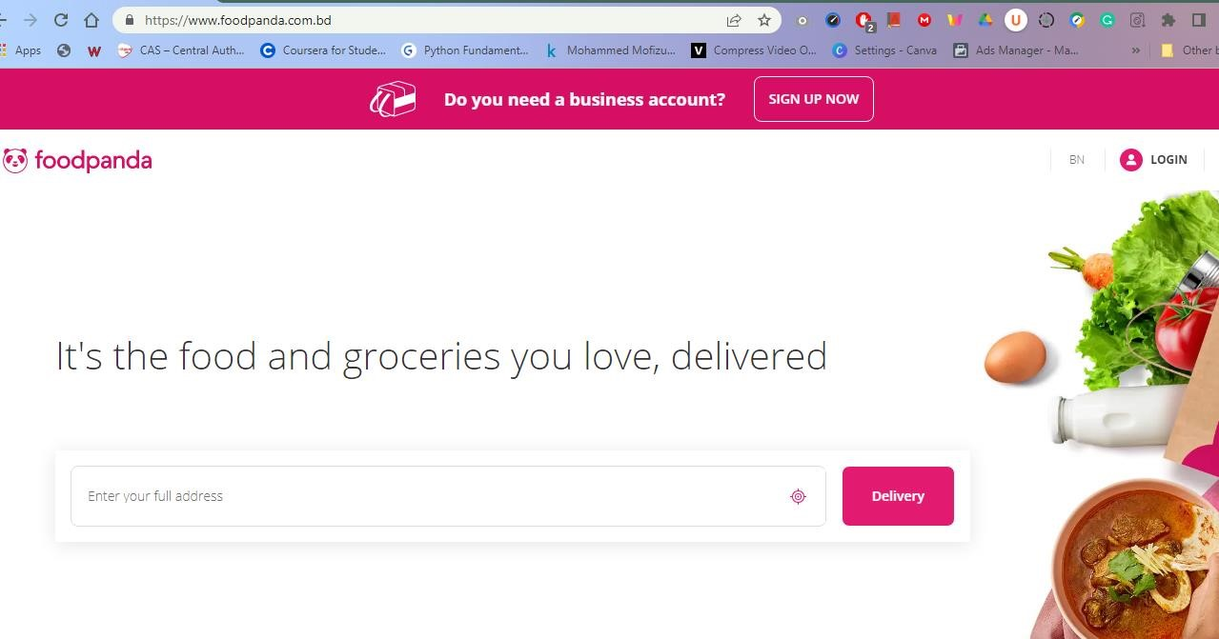

*Fig.01: Food Panda Open in Chrome Browser*

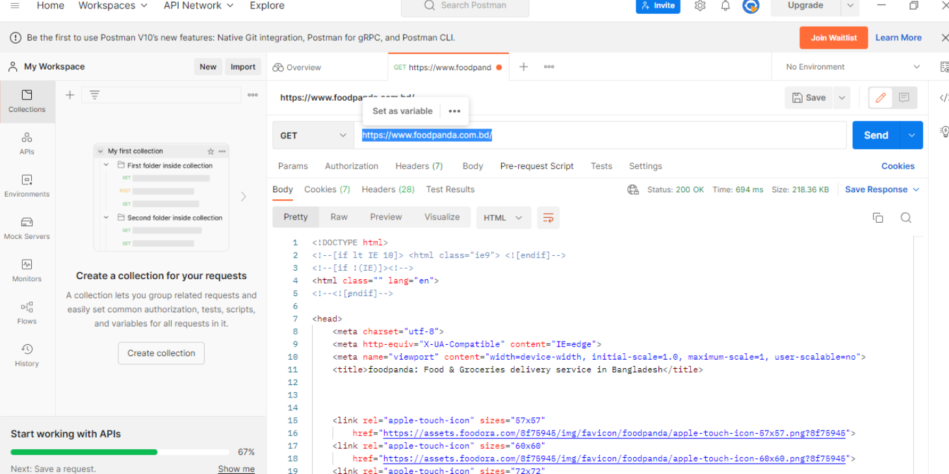

*Fig.02: Food Panda tested connectivity on Postman testing tool*

* **Selenium IDE-testing tool**

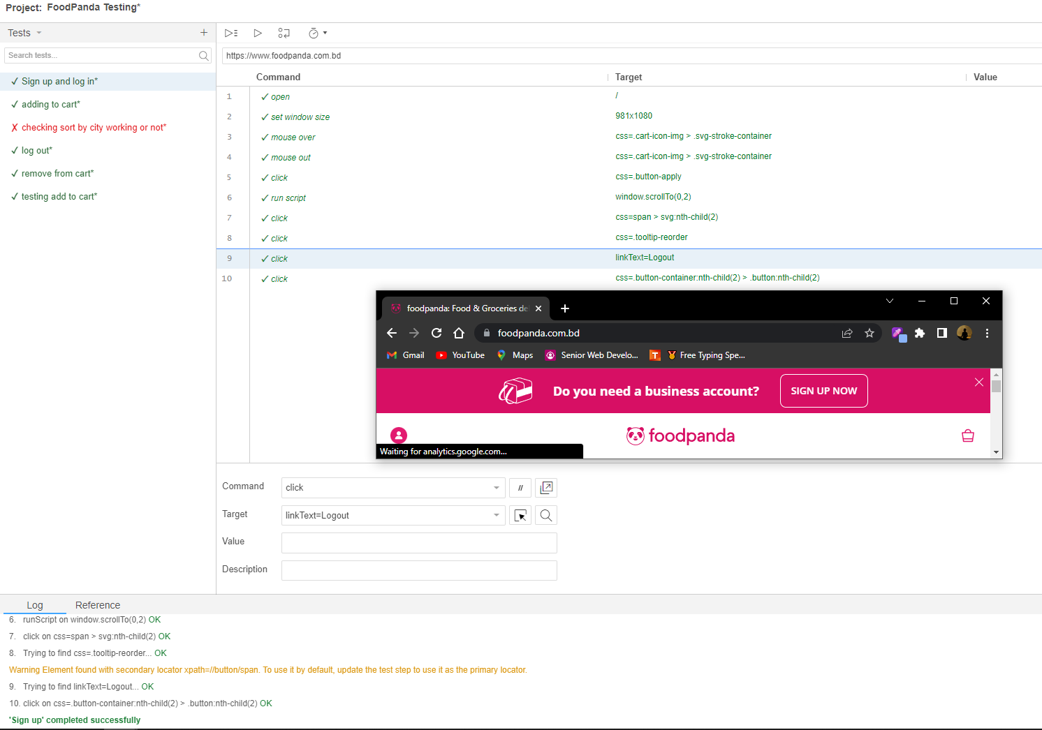 *Fig.03: Selenium IDE for testing interactions and basic functionality of food panda site.*

## 6.3 Meetings:

This entire project duration is about 1 week. Every day our group member has to report how much progress was done. All the members also provided suggestion for improving various functionality.

# 7. TEST CASES/TEST ITEMS (Food Panda)

**7.1** **Sign Up:**

This Test case is for testing the sign-up details

|  |  |  |  |  |
| --- | --- | --- | --- | --- |
| Project Name: Online based food delivery system -(Food Panda) | | | Test Designed by: Amir Hossain | |
| Test Case ID: FP_01 | | | Test Designed date: 01, dec,2022 | |
| Test Priority (Low, Medium, High): High | | | Test Executed by: Amir Hossain | |
| Module Name: Sign Up | | | Test Execution date: 01, dec,2022 | |
| Test Title: Verify sign up sending verification code | | |  | |
| Description: Test the sign-up verification | | |  | |
| Precondition: User should have valid email or phone number | | |  | |
| Test Steps | Test Data | Expected Results | Actual Results | Status  (Pass/Fail) |
| 1. Go to the website sign up page 2. Enter first name 3. Enter last name 4. Enter valid email 5. Enter valid phone number 6. Select reason for choosing us 7. Click sign up | First Name: Amir    Last Name: Hossain  Email:  Amirhossain121@gmail.com    Phone no:01712345678 | Verification code should be sent to the user email or phone no | As expected, | Pass |
| Post Condition: User should get the verification code and confirm it and get sign up in to the system successfully. | | |  | |

## 7.2 Login:

This Test case tests the login that a student can login using their id and password

|  |  |  |  |  |
| --- | --- | --- | --- | --- |
| Project Name: Online based food delivery system -(Food Panda) | | | Test Designed by: Amir Hossain | |
| Test Case ID: FP_02 | | | Test Designed date: 02, dec,2022 | |
| Test Priority (Low, Medium, High): High | | | Test Executed by: Amir Hossain | |
| Module Name: Login | | | Test Execution date:02, dec,2022 | |
| Test Title: Verify login with valid email or phone number and password | | |  | |
| Description: Test the system login | | |  | |
| Precondition: User should have registered mail address/phone number and password | | |  | |
| Test Steps | Test Data | Expected Results | Actual Results | Status  (Pass/Fail) |
| 1. Go to the login page 2. Enter valid email/ phone number 3. Enter password  4. Click login | Email:  Amirhossain121@gmail.com  or  Phone: 01712345678    password: 123456 | User should login to the system | As expected, | Pass |
| Post Condition: User should have logged in to the system successfully | | |  | |

## 7.3 View Food List

This Test case will check that the feature is showing all the product with their corresponding details or not

|  |  |  |  |  |
| --- | --- | --- | --- | --- |
| Project Name: Online based food delivery system -(Food Panda) | | | Test Designed by: Md. Mahin Hasan | |
| Test Case ID: FP_03 | | | Test Designed date: 02, dec,2022 | |
| Test Priority (Low, Medium, High): High | | | Test Executed by: Md. Mahin Hasan | |
| Module Name: View Food List | | | Test Execution date:03, dec,2022 | |
| Test Title: Showing all the product with their corresponding details | | |  | |
| Description: Test all the products are visible or not | | |  | |
| Precondition: Some food items must be added before viewing cart. | | |  | |
| Test Steps | Test Data | Expected Results | Actual Results | Status  (Pass/Fail) |
| 1. Go to the website in Food Panda 2. Login to the page 3. Go to the Food page |  | User should see all the food items in  details with the price | As expected, | Pass |
| Post Condition: Added food items must view in the cart section. | | |  | |

## 7.4 Add to Cart

This Test case is for checking the user whether he/she can order multiple food items.

|  |  |  |  |  |
| --- | --- | --- | --- | --- |
| Project Name: Online based food delivery system -(Food Panda) | | | Test Designed by: Md. Mahin Hasan | |
| Test Case ID: FP_04 | | | Test Designed date: 04, dec,2022 | |
| Test Priority (Low, Medium, High): High | | | Test Executed by: Md. Mahin Hasan | |
| Module Name: Add to cart | | | Test Execution date:04, dec,2022 | |
| Test Title: Adding items in the cart | | |  | |
| Description: Test whether multiple items are added in the cart | | |  | |
| Precondition (If any): Cart should be empty. | | |  | |
| Test Steps | Test Data | Expected Results | Actual Results | Status  (Pass/Fail) |
| 1. Go to the Food Panda page. 2. Select multiple food items. |  | User should see all the selected items on cart. | As expected, | Pass |
| Post Condition: Added food items must show in the cart section. | | |  | |

## 7.5 Payment Method

This Test case tests the payment method. There is used two types of payment method. Users can either pay with cash or using mobile banking named Bkash.

|  |  |  |  |  |
| --- | --- | --- | --- | --- |
| Project Name: Online based food delivery system -(Food Panda) | | | Test Designed by: Fahmida Haque | |
| Test Case ID: FP_05 | | | Test Designed date: 06, dec,2022 | |
| Test Priority (Low, Medium, High): High | | | Test Executed by: Fahmida Haque | |
| Module Name: Cash Payment Method | | | Test Execution date: 06, dec,2022 | |
| Test Title: Showing options for paying with cash | | |  | |
| Description: Test Bkash cash validation | | |  |  |
| Precondition (If any): Items should be added to the cart. | | |  |  |
| Test Steps | Test Data | Expected Results | Actual Results | Status  (Pass/Fail) |
| 1. Add 1 burger and 1 coke 2. Pay with Bkash. | Pay 245 BDT by Bkash | The system must  accept cash 245 BDT | As expected, | Pass |
| Post Condition: Must accept Bkash terms and conditions. | | |  |  |

## 7.6 Menu

This Test case is for checking the user whether he/she can show all menu option

|  |  |  |  |  |
| --- | --- | --- | --- | --- |
| Project Name: Online based food delivery system -(Food Panda) | |  | Test Designed by: Fahmida Haque | |
| Test Case ID: FP_06 | |  | Test Designed date: 07, dec,2022 | |
| Test Priority (Low, Medium, High): Medium | |  | Test Executed by: Fahmida Haque | |
| Module Name: Menu | |  | Test Execution date: 07, dec,2022 | |
| Test Title: Showing menu option | |  |  | |
| Description: Test all the menu option | |  |  | |
| Precondition (If any): Login | |  |  | |
| Test Steps | Test Data | Expected Results | Actual Results | Status  (Pass/Fail) |
| 1. Go to the website page 2. Login to the page 3. Go to menu option |  | In menu User can find many options like setting, profile, vouchers, help center, privacy, logout | As expected, | Pass |
| Post Condition: | |  |  | |

## 7.7 Settings:

The test case is for the settings options

|  |  |  |  |  |
| --- | --- | --- | --- | --- |
| Project Name: Online based food delivery system -(Food Panda) | | | Test Designed by: Lokman Hossain | |
| Test Case ID: FP_07 | | | Test Designed date: 07, dec,2022 | |
| Test Priority (Low, Medium, High): Low | | | Test Executed by: Lokman Hossain | |
| Module Name: Settings | | | Test Execution date: 08, dec,2022 | |
| Test Title: Test all the settings option | | |  | |
| Description: Test all the orders are visible or not | | |  | |
| Precondition: User have logged in and went to system menu | | |  | |
| Test Steps | Test Data | Expected Results | Actual Results | Status  (Pass/Fail) |
| 1. Go to Food Panda page 2. Login to the page 3. Go to menu bar 4. Then from menu option click setting   option | . | In setting section user can change the language, floating icon, receive push notifications, receive offers by email | As expected, | Fail |
| Post Condition: | | |  | |

## 7.8 Change Password

This Test case is for Change password

|  |  |  |  |  |
| --- | --- | --- | --- | --- |
| Project Name: Online based food delivery system -(Food Panda) | | | Test Designed by: Lokman Hossain | |
| Test Case ID: FP_08 | | | Test Designed date: 09, dec,2022 | |
| Test Priority (Low, Medium, High): Medium | | | Test Executed by: Lokman Hossain | |
| Module Name: Change password | | | Test Execution date: 09, dec,2022 | |
| Test Title: Test the changing password | | |  | |
| Description: Test the password is changing or not | | |  | |
| Precondition: Student have to logged into the system then went to system menu after that go to profile option | | |  | |
| Test Steps | Test Data | Expected Results | Actual Results | Status  (Pass/Fail) |
| 1. Login to the website 2. Go to menu option 3. Then from menu | Password: 45897 | Password should be added by the user and stored in database. | As expected, | Pass |
| option go to profile option |  |  |  |  |
| Post Condition: Database should be updated password | | |  | |

## 7.9 Update Profile:

This Test case is for update the profile

|  |  |  |  |  |
| --- | --- | --- | --- | --- |
| Project Name: Online based food delivery system -(Food Panda) | | | Test Designed by: Nafis Sadik | |
| Test Case ID: FP_09 | | | Test Designed date: 10, dec,2022 | |
| Test Priority (Low, Medium, High): Low | | | Test Executed by: Nafis Sadik | |
| Module Name: Update Profile | | | Test Execution date: 10, dec,2022 | |
| Test Title: Test the update profile | | |  | |
| Description: Test the profile is update or not | | |  | |
| **Precondition:** User have logged in and went to system menu | | |  | |
| Test Steps | Test Data | Expected Results | Actual Results | Status  (Pass/Fail) |
| 1. Login to the website 2. Go to menu option 3. Click profile   option | Email:  nafisSadik@gmail.com First Name: Nafis  Last Name: Sadik  Phone No: 01312345678 | User provide information email and phone number should be verified and User edit their name and click save it will show that the profile is update | As expected, | Pass |
| Post Condition: After changing their name email, phone number profile show is update | | |  | |

# 8. ITEM PASS/FAIL CRITERIA

Nine test cases in total were used to implement the Food Panda. First off, 95% of the test cases passed when they were applied to the system during unit testing. But regrettably, 5% of attempts failed. Due to several database query-related problems, the test cases were failing. All test cases were successfully executed and passed the test when they were applied after solving query-related issues.

# 9. TEST DELIVERABLES

* Test plan
* Test results documents
* Test summary
* Defect reports and summaries

# 10. TESTING SCHEDULE

Time has been allocated within the project plan for the following testing activities.

|  |  |  |
| --- | --- | --- |
| **Task Name** | **Duration** | **Responsible** |
| Requirement Analysis | 6 days | Project Manager |
| Design | 7 days | Project Manager |
| Writing codes | 18 days | Developers |
| Unit Test | 12 days | Developers |
| Documentation | 9 days | Test Engineer |
| Maintenance | 15 days | Developers & End User |

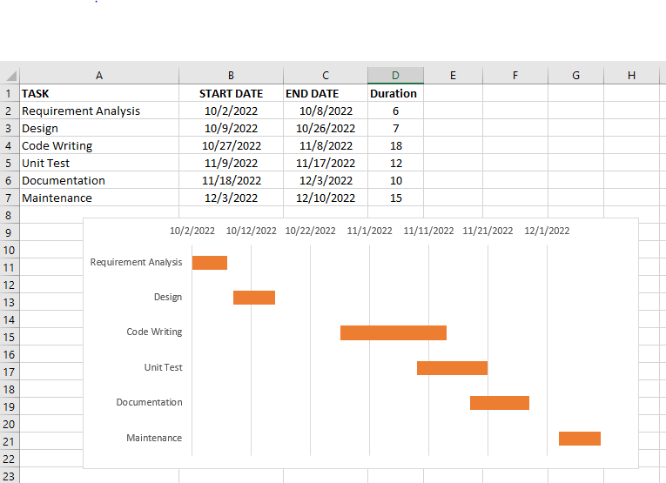

Fig.08: Test Schedule

# 11. PLANNING RISKS AND CONTINGENCIES

This Food Panda may be pricey and the upkeep may be a problem because the hardware and software must cooperate. There is relatively little interaction between people. Given that it is a self-service system, the user must be cautious when choosing the food products.